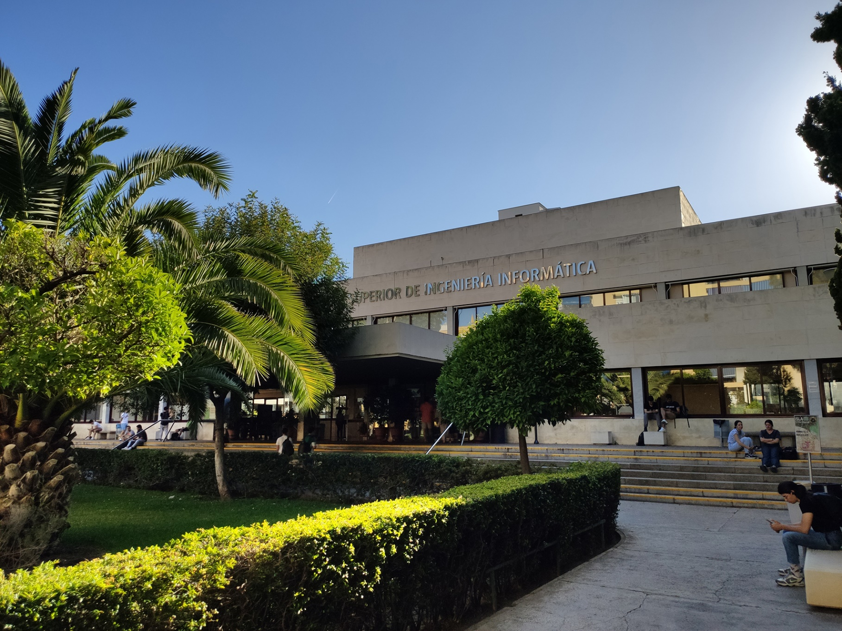

|  |
| --- |
| Analysis Report  Group |
| Members:   1. Jesús Cárdenas Conejo   (jescarcon@alum.us.es)   1. Antonio José López Cubiles   (antlopcub@alum.us.es)   1. Pedro Jesús Ruiz Aguilar   (pedruiagu1@alum.us.es)   1. Ismael Ruiz Jurado   (ismruijur@alum.us.es) |
| 17-02-2023  Group: C1.02.10  Repository: https://github.com/jescarcon/Acme-L3-D01-23.1 |



Table of Contents

Executive Summary 3

Version History 4

Introduction 5

Contents 6

Conclusions 7

Bibliography 8

# Executive Summary

In this report you will find relative information of our first deliverable in an Analysis Report structure. This document shows how many analyses record we have redacted, the content of those reports and a link to the forum where a lecturer gave us insight, if the requirement needed an outside help for interpretation.

# Version History

|  |  |  |
| --- | --- | --- |
| Version | Date | Description of changes |
| 1.0 | 17/02/2023 | Creation of the Analysis Report Document. |

# Introduction

In this report we are going to describe the analysis and decision that we have made in the process of finding a solution for the problem that is stated on the deliverable 1, the documentation requirement we decided that we are going to only take in account the requirements that involves touching the code because the documentation has no decision to be made because we will follow the indications on the annexes, the 2 requirements that we choose to analyze in this report are the non-functional one and the mandatory managerial one, for each of them we will provide a verbatim copy of the exercise, the analysis and the decision that have been made in seek of the solution and the link to the forum for the feedback of the lecturer.

# Contents

Analysis of Requirement #1:

Verbatim copy of the exercise:

“Instantiate and customize the appropriate starter project so that you can work on this project. Make sure that the name of your project folder, maven configuration (pom.xml), and database is “Acme-L3-D〈dd〉”, where “〈dd〉” denotes the deliverable number using two digits. Make sure that you have followed the instructions in the “On Your Deliverables” document to package and deliver your work. This requirement must be fulfilled in this and every subsequent group or individual deliverable.”

After reading this text we concluded that we needed to change the name in our project folder, in our project repository, the name on the file pom.xml and the name of the database on the dbeaver program, we quickly realized that we also we need to update the name of our database in the proyect for it to connect to the renamed database, after some strugle we reached the profile.properties changing the old name for the new one, doing so we could connect to our renamed database.

Customizing was also needed so we change the logo, banner and icon on the page and on the console, the images on the page were created by us following the stipulated sizes.

Analysis of Requirement #2:

Verbatim copy of the exercise:

“The system must be internationalized in English and Spanish. Other mainstream languages are welcome, but not required. This requirement must be fulfilled in this and every subsequent group or individual deliverable.”

After reading the statement and checking the project, we saw that it already had an English and Spanish version so we decided to not add another and leave like that because we needed more time to do other reports and requirements.

# Conclusions

The group has followed the theory material, so we didn’t have much trouble interpretating the exercises and doing it, only in the changing the name of the database because we had trouble with the naming

# Bibliography

Intentionally blank.